Kinder Engineering 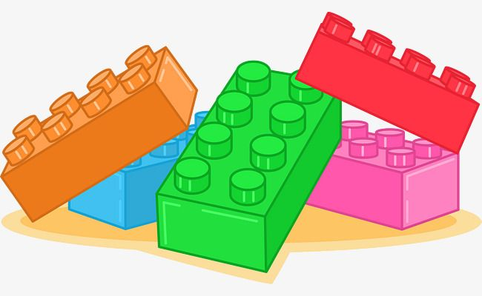 Year At A Glance

August 2025 |  | September 2025
*Students will learn the Rules/Expectations of Engineering. |  | *Students will continue learning about the Alphabet.
*Students will begin learning the Alphabet. Starting with Letter Aa. |  | *This month, students will be focusing on Letters Bb, Cc, Dd and Ee.
*They will learn how to demonstrate the Letter Aa using their bricks. |  | *They will learn how to demonstrate each Letter using their bricks.
*They will then be able to build objects that begin with the Letter Aa. |  | *They will then be able to build objects that begin with each Letter.
October 2025 |  | November 2025
*Students will be focusing on Letters Ff, Gg, Hh, Ii and Jj. |  | *Students will be focusing on Letters Kk, Ll and Mm.
*They will learn how to demonstrate each Letter using their bricks. |  | *They will learn how to demonstrate each Letter using their bricks.
*They will then be able to build objects that begin with each Letter. |  | *They will then be able to build objects that begin with each Letter.
December 2025 |  | January 2026
*Students will be focusing on Letters Nn, Oo and Pp. |  | *Students will be focusing on Letters Qq, Rr, Ss and Tt.
*They will learn how to demonstrate each Letter using their bricks. |  | *They will learn how to demonstrate each Letter using their bricks.
*They will then be able to build objects that begin with each Letter. |  | *They will then be able to build objects that begin with each Letter.
February 2026 |  | March 2026
*Students will be focusing on Letters Uu, Vv and Ww. |  | *Students will be focusing on Letters Xx, Yy and Zz.
*They will learn how to demonstrate each Letter using their bricks. |  | *They will learn how to demonstrate each Letter using their bricks.
*They will then be able to build objects that begin with each Letter. |  | *They will then be able to build objects that begin with each Letter.
April 2026 |  | May 2026
*Students will learn about Numbers Zero, One, Two, Three and Four. |  | *Students will learn about Numbers Five, Six, Seven, Eight, Nine and Ten.
*They will learn how to demonstrate each Number using their bricks. |  | *They will learn how to demonstrate each Number using their bricks.
*They will then use their knowledge to solve simple math problems. |  | *They will then use their knowledge to solve simple math problems.
Please note: Lessons may be changed, added, or deleted.

